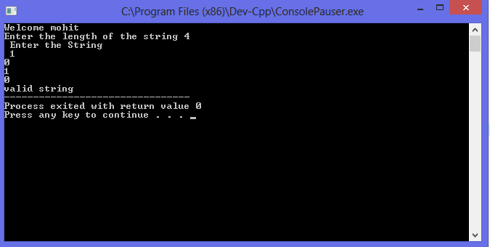

***Expermint No***.___

Q__ -> Wap in c to take a string by user and accept a string in (0^*1^*) format by a dfa ?

***Source Code*** -->

#include<stdio.h>

#include<conio.h>

int main()

{

int a[50],i,c=1,l;

printf("Welcome mohit \n");

printf("Enter the length of the string ");

scanf("%d",&l);

if(l>0)

{

printf(" Enter the String \n ");

for(i=0;i<l;i++)

{

scanf("%d",&a[i]);

}

}

else

{printf("String is empty means only containg the Epsilon \n \n");

}

for(i=0;i<l;i++)

{

if(a[i]==0||a[i]==1||a[i]==NULL)

{

}

else

{

c=c+1;

}

}

if(c==2)

printf("invalid string");

else

printf("valid string");

return 0;

}